S5. Data Extraction Form
The dataset used for synthesis/meta-analysis was stored in the S6.Framework_elements sheet of the S6 (Extracted_Data).xlsx file. The S6.ABCE_Criteria_Keywords and S6.ABCE_Result sheets in the S6.Extracted Dataset.xlsx file respectively contain the ABCE criteria keywords and their corresponding analysis outputs. Likewise, the S6.UNESCO_Criteria_Keywords and S6.UNESCO_Result sheets present the UNESCO criteria keywords and results. The S6.ABCE-UNESCO sheet consolidates comparative data between the two frameworks and incorporates adjustments based on expert qualitative evaluation.
The first screening criterion was topic relevance, with records documented in the 1st Screening: Topic relevance field of the S4.Screening Logs (Records) sheet in S4.Screening Logs.xlsx File. The second screening applied a scope check, recorded in the 2nd Screening: Scope check field. The third screening consisted of a final content check for specific components, with logs stored in the 3rd Screening: Final content check_Specific components field. The Reason field documents the justification for each screening decision.

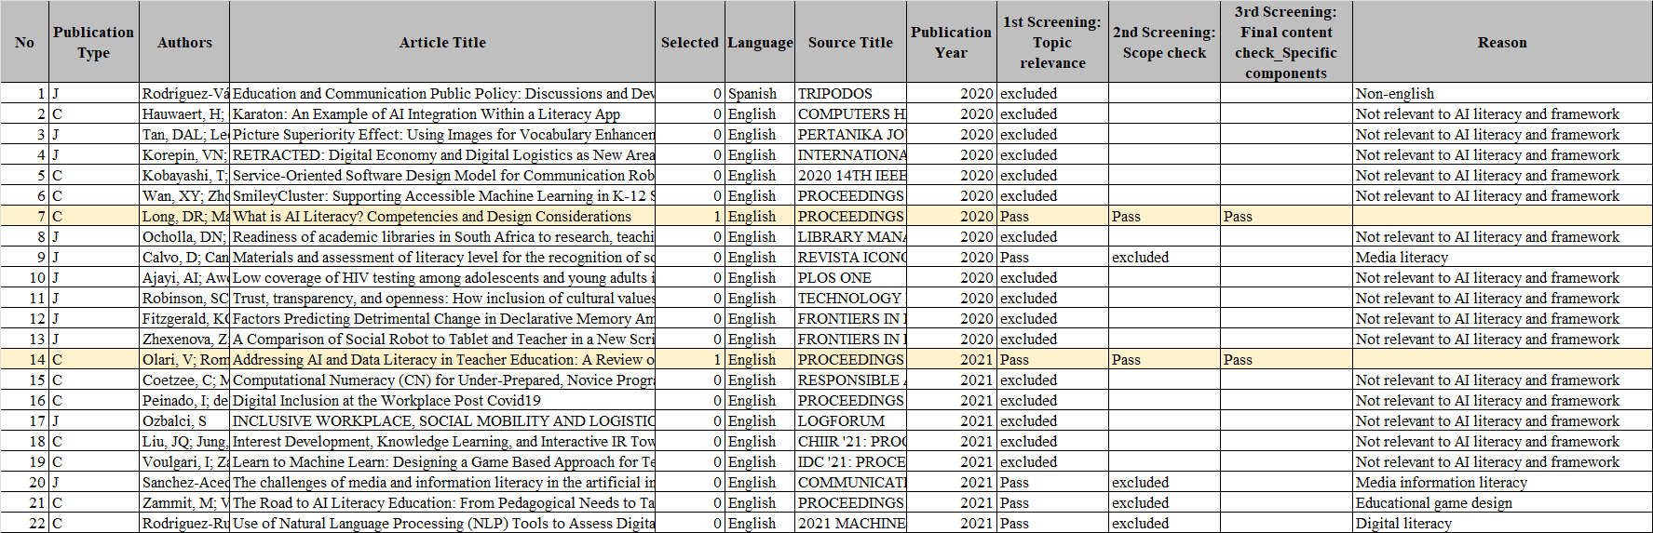
Figure S5.1: S4.Screening Logs (Records) sheet in S4.Screening Logs.xlsx File

The final results were recorded in the S6.ABCE-UNESCO sheet and submitted as Supplementary File S6.Extracted Dataset.xlsx. All related materials, including S4.Screening Logs.xlsx and S6.Extracted Dataset.xlsx, are consolidated in the Supplementary Materials folder and made publicly available via GitHub. By adjusting the file path specified in the released source code, readers can directly reproduce the analysis and access the corresponding results.
The S4.Screening Logs (Elements) sheet includes the Article Number and Article Title for the 41 screened studies, as well as the Framework Elements extracted through expert qualitative evaluation. The final No field denotes the corresponding index aligned with the No field in the S4.Screening Logs (Records) sheet.

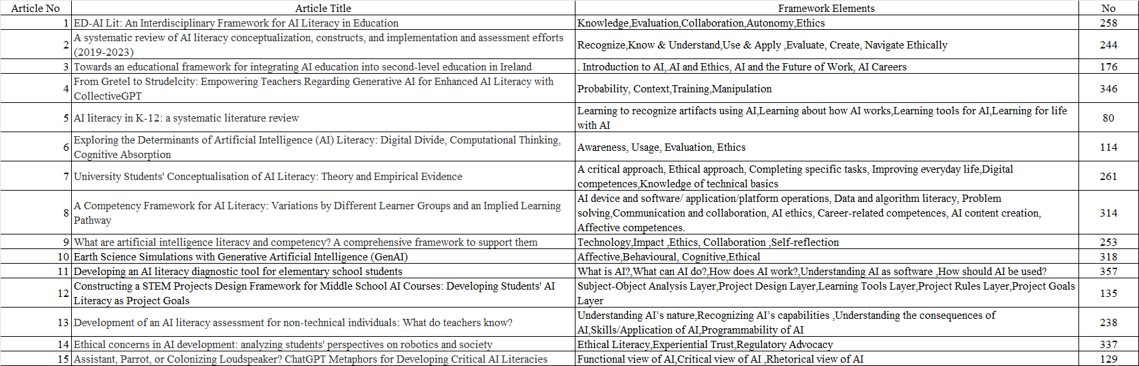
Figure S5.2: S4.Screening Logs (Elements) sheet in S4.Screening Logs.xlsx File

The S7.Evidence Tables sheet in Supplementary File S7.Evidence Tables.xlsx summarizes the results of the ABCE and UNESCO analyses, including the number of keywords identified for each category, the number of duplicates removed, and the final number of keywords retained. Remains represents the number of keywords retained after processing that were ultimately included in the final table. All related materials, including S7.Evidence Tables, are consolidated in the Supplementary Materials folder and made publicly available via GitHub.

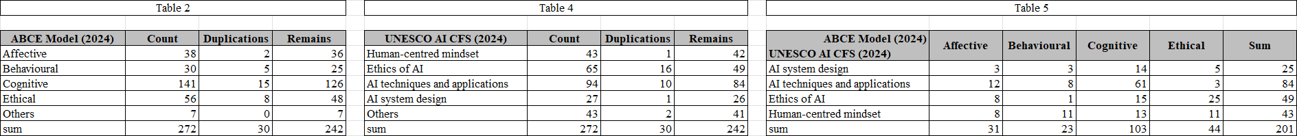
Figure S5.3: Evidence table includes information for verification

The S6.ABCE_Criteria_Keywords sheet lists the criteria keywords extracted from ABCE-related studies through expert qualitative evaluation.

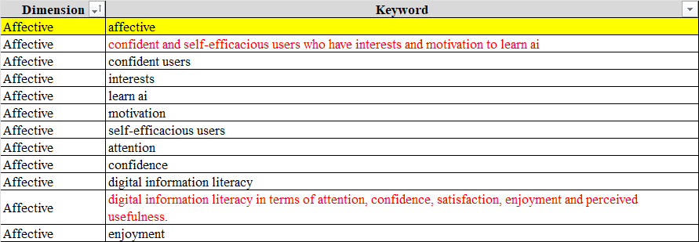
Figure S5.4: Criteria keywords extracted based on expert qualitative evaluation in the S6.ABCE_Criteria_Keywords sheet

In the S6.ABCE_Result sheet, the Paper No. field corresponds to the Article Number, and the Keyword field contains the 272 extracted keywords. The fields Sim_max_Affective, Sim_max_Behavioural, Sim_max_Cognitive, and Sim_max_Ethical present the maximum cosine similarity scores between each keyword and the criteria keywords for the respective categories. The BestSim_max field indicates the highest similarity value among the four categories, and the BestCategory_max field identifies the corresponding optimal category.

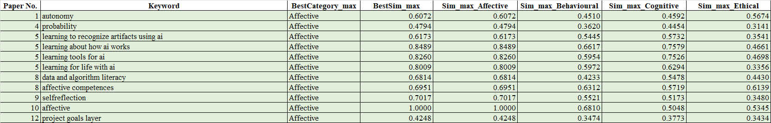
Figure S5.5: ABCE analysis results in the S6.ABCE_Result sheet

The S6.UNESCO_Criteria_Keywords sheet lists the criteria keywords extracted from UNESCO-related studies based on expert qualitative evaluation. The S6.UNESCO_Result sheet records the calculated results, following the same calculation procedure used for the S6.ABCE_Result sheet.

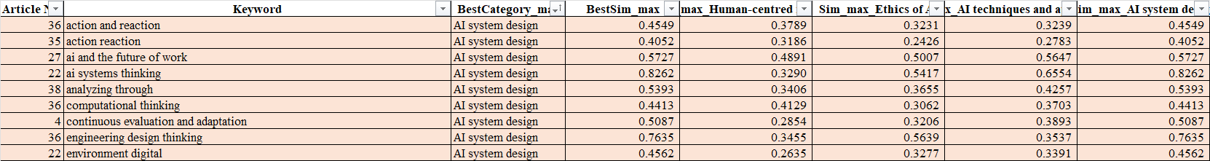
Figure S5.6: UNESCO analysis results in the S6.ABCE_Result sheet

The S6.ABCE-UNESCO sheet integrates the ABCE and UNESCO classification results and includes adjustments derived from expert qualitative evaluation.

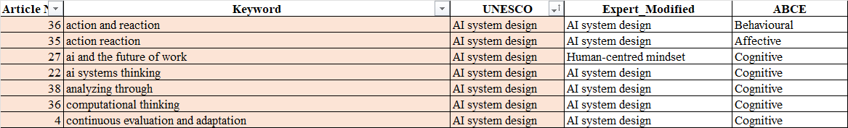
Figure S5.7: Final results modified based on expert qualitative evaluation in the S6.ABCE-UNESCO sheet

